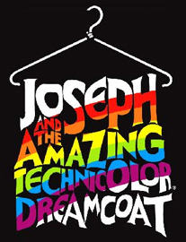

With a crash of drums and a flash of light, Gareth Gates as **Joseph** has burst into the West End in his dazzling coat of many colours.

In an energetic and vibrant new staging of the record breaking 1990s London Palladium production, Tim Rice and Andrew Lloyd Webber’s family classic is entertaining a whole new generation.

This colourful retelling of the biblical story about dreamboat **Joseph**, his uncanny abilities and his designer coat sings out to young and old alike with a score which is wall to wall hits - including Close Every Door and Any Dream Will Do – and is now booking with Gareth Gates

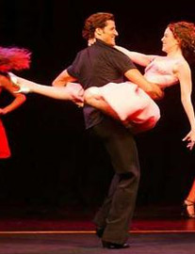

A great girls night and must see for fans of the '80s film, **Dirty Dancing**, The Classic Story On Stage has been a hit on **London's West End** since it opened in November 2007; even before it even opened in London, the show had sold out for the first six months of its run.

If you are not familliar with the plot of **Dirty Dancing**, it is based on the romantic comming of age film set in 1963, about Frances 'Baby' Houseman, who, whilst on a family holiday meets, dances (a lot), and ultimately falls in love with Jonny Castle the resort's rough around the edges dance teacher, played by Patrick Swayze.

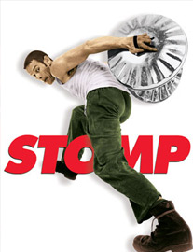

**Stomp** is a spectacular show which creates unconventional instruments out of the most conventional every day objects. **Stomp** exhilarating display of percussion, rhythm and movement is a winner with all age groups, stimulating and entertaining the audience like no other show!

The performers of **Stomp** use a variety of everyday objects - from dustbin lids to water bottles - to great effect, creating some of the most infectious and unusual sounds ever to be seen on stage

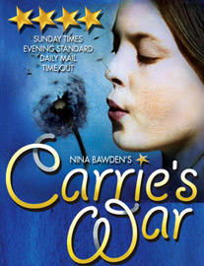

[](http://www.theatresonline.com/theatres/london-west-end-theatres/adelphi-theatre-london/adelphi-london/current-show.html)

With a crash of drums and a flash of light, Gareth Gates as **Joseph** has burst into the West End in his dazzling coat of many colours.

In an energetic and vibrant new staging of the record breaking 1990s London Palladium production, Tim Rice and Andrew Lloyd Webber’s family classic is entertaining a whole new generation.

This colourful retelling of the biblical story about dreamboat **Joseph**, his uncanny abilities and his designer coat sings out to young and old alike with a score which is wall to wall hits - including Close Every Door and Any Dream Will Do – and is now booking with Gareth Gates until 18 July 2009.

**Joseph** is nothing short of a phenomenon and it is one of the most endearing shows of all time. Tim Rice and Andrew Lloyd Webber's sparkling family musical has been a hit all over the world. It continues to enjoy huge success across the country with standing ovations at every performance.

With the liveliest, most energetic company of actors, singers and dancers, **Joseph** is brimming with non-stop action, laughter and infectious fun that will delight both the young and young at heart. Retelling the Biblical story of Jacob's favourite son, **Joseph**, his eleven brothers and the coat of many colours, this magical musical is full of unforgettable songs including, "Close Every Door To Me" and "Any Dream Will Do", which was voted the Broadway Song of the Year.

[**Dirty Dancing**](http://www.theatresonline.com/theatres/london-west-end-theatres/aldwych-theatre-london/aldwych-london/current-show.html) ***at the*** [***Aldwych Theatre***](http://www.theatresonline.com/theatres/london-west-end-theatres/aldwych-theatre-london/aldwych-london/index.html)

[](http://www.theatresonline.com/theatres/london-west-end-theatres/aldwych-theatre-london/aldwych-london/current-show.html)

A great girls night and must see for fans of the '80s film, **Dirty Dancing**, The Classic Story On Stage has been a hit on **London's West End** since it opened in November 2007; even before it even opened in London, the show had sold out for the first six months of its run.

If you are not familliar with the plot of **Dirty Dancing**, it is based on the romantic comming of age film set in 1963, about Frances 'Baby' Houseman, who, whilst on a family holiday meets, dances (a lot), and ultimately falls in love with Jonny Castle the resort's rough around the edges dance teacher, played by Patrick Swayze.

All this occurs to a by now familliar '80s soundtrack culminating in the finale "(I've Had) The Time Of My Life", performed by Bill Medley and Jennifer Warnes.

**Dirty Dancing** The London musical is definitely worth going to see. Turning the film into a stage show is achieved through a mix of mulimedia, a series of LED screens, display video, stills and live-feed film, all adding depth and a sense of movement.

[**Stomp**](http://www.theatresonline.com/theatres/london-west-end-theatres/ambassadors-theatre-london/ambassadors-theatre-london/current-show.html) ***at the*** [***Ambassadors Theatre***](http://www.theatresonline.com/theatres/london-west-end-theatres/ambassadors-theatre-london/ambassadors-theatre-london/index.html)

[](http://www.theatresonline.com/theatres/london-west-end-theatres/ambassadors-theatre-london/ambassadors-theatre-london/current-show.html)

**Stomp** is a spectacular show which creates unconventional instruments out of the most conventional every day objects. **Stomp** exhilarating display of percussion, rhythm and movement is a winner with all age groups, stimulating and entertaining the audience like no other show!

The performers of **Stomp** use a variety of everyday objects - from dustbin lids to water bottles - to great effect, creating some of the most infectious and unusual sounds ever to be seen on stage.

Combining percussion, dance, theatre and comedy, **Stomp** remains one of the most original shows in the world.

**Stomp** is an international hit, **Stomp** is not to be missed!

[**Carries War**](http://www.theatresonline.com/theatres/london-west-end-theatres/apollo-theatre-london/apollo-london/current-show.html) ***at the*** [***Apollo Theatre***](http://www.theatresonline.com/theatres/london-west-end-theatres/apollo-theatre-london/apollo-london/index.html)

[](http://www.theatresonline.com/theatres/london-west-end-theatres/apollo-theatre-london/apollo-london/current-show.html)

**Carrie's War** is the timeless tale of the adventures of Carrie Willow; a young girl evacuated from London during World War II. Packed off to the Welsh mining valleys with her younger brother Nick, she must adjust to life without her parents - under the guardianship of the dictatorial Mr. Evans and his sister.

Returning as an adult, Carrie's memories come alive; whisking us on a breathtaking journey into the past..



Disney presents The Lion King - the award-winning musical.

Set against the majesty of the Serengeti Plains and to the evocative rhythms of Africa, Disney's multi-award winning musical, **The Lion King**, will redefine your expectations of theatre.

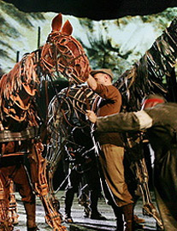

At the outbreak of World War One, Joey, young Albert's beloved horse, is sold to the cavalry and shipped to France. He's soon caught up in enemy fire, and fate takes him on an extraordinary odyssey, serving on both sides before finding himself alone in no man's land. Albert cannot forget Joey and, still not old enough to enlist, he embarks on a treacherous mission to find him and bring him home.

'So exhilarating it makes you rejoice to be alive. Its sheer skill and invention are awe-inspiring' - The Times

'War Horse only confirms the National's extraordinary knack of turning children's literature into the finest drama. Stunning' - Sunday Times

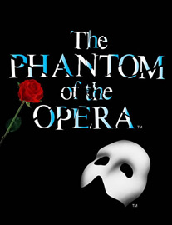

The legendary, unforgettable musical The **Phantom of The Opera** traces the tragic love story of a beautiful opera singer and a young composer shamed by his physical appearance into a shadowy existence beneath the majestic Paris Opera House.

A newly installed state-of-the-art digital sound system now makes Andrew Lloyd Webber's spine-tingling score sound better than ever. The combination of opulent sets and costumes, and fabulous special effects creates a theatrical experience not to be missed.

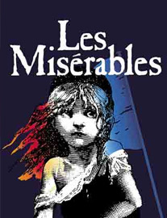

**Les Misérables** (pronounced /le? ?m?z?'r??b/; French pronunciation: [le mize'?a?bl?]), colloquially known as Les Mis or Les Miz, is a **musical** composed in 1980 by the French composer Claude-Michel Schönberg with a libretto by Alain Boublil. Sung through, it is perhaps the most famous of all French musicals and one of the most performed musicals worldwide. On October 8, 2006, the show celebrated its 21st anniversary and became the longest-running West End musical in history the following performance, and is still running (though it has changed venues)

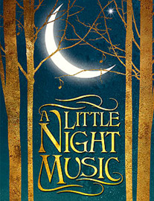

The critically acclaimed, sell-out Menier Chocolate Factory production of Stephen Sondheim and Hugh Wheeler’s musical **A Little Night Music**, directed by Trevor Nunn, transfers to the Garrick Theatre for a strictly limited season.

**A Little Night Music**, based on Ingmar Bergman's film Smiles of a Summer Night, **A Little Night Music** is set in 19th -century Sweden where affairs of the heart are uppermost in everyone's thoughts.

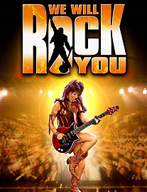

**We Will Rock You** is set in the future, on a place once called Earth. Globalisation is complete. Everyone watches the same movies, wears the same clothes, and thinks the same thoughts. A safe, happy Ga Ga world.

The Company Computers generate the music and the kids download it. All musical instruments are banned. But resistance is growing. A hero is needed.